Sprint Backlog G6
Project Name: Bistro Management System
Assignment 2 – Sprint 2 Backlog Group Number: 6
Submission date: 7/12/2025

Team Members:
Weaam: 213283062, Weaam.Asad@e.braude.ac.il.
Oneel : 213010374, Oneel.Abed@e.braude.ac.il.
Amal : 213559271, amal.mulla@e.braude.ac.il.
Danial : 326285111, danial.abu.yamn@e.braude.ac.il.

In accordance with the project requirements, our team has adopted the SCRUM methodology to manage the development lifecycle. We have divided the semester's work into distinct Sprints:
Sprint 1 (Analysis & Planning): Covered Assignment 1 (Requirements, Use Case, Initial Planning)>> Status: 99% Completed.
Sprint 2 (Design & Construction): Covers Assignment 2 (Detailed Design, Prototyping, Architecture)>> Status: In Progress (Current Submission).

Scrum Roles Definition:
For the second sprint the team has allocated specific Scrum roles to ensure an agile and efficient development process.
Scrum Master: Weaam
The Scrum Master is responsible for the process and the team's efficiency.
Schedule Management: Maintaining and updating the Project Plan in the ToDoList software, ensuring tasks are completed according to the weekly schedule.
Removing Impediments: Solving technical blockers for the development team (e.g., issues with GitHub repositories, OCSF framework configuration, or Visual Paradigm license).
Process Enforcement: Facilitating weekly synchronization meetings (simulating "Daily Scrum") to track progress and identify risks early
Submission Integrity: Verifying that all deliverables (JAR files, UML diagrams, and documents) meet the submission standards and are packaged correctly in the final ZIP file.
Product Owner (PO): Oneel
The Product Owner represents the stakeholders and focuses on the product's value and requirements.
Backlog Management: Defining the "User Stories" for the prototype (e.g., "As a user, I want to update the number of guests") and prioritizing them in the Sprint Backlog.
Requirement Definition: Specifying the exact structure of the Database schema (specifically the Order table fields: order_date, number_of_guests, etc.) to match the assignment description.
Acceptance Testing: Performing the final validation of the prototype. This includes verifying that data updated via the Client GUI is correctly reflected in the Database by checking the DB directly.
Quality Assurance: Ensuring that the UML diagrams (Activity, Class, Sequence) accurately reflect the logic implemented in the prototype code.

Sprint Backlog
Week & Date | Task Name | Description | Est. Hours | Assignee
Week 4  22/11 – 23/11 | Project Structure Setup | Setting up the IDE project, importing OCSF and JDBC libraries, and creating package structure. | 2 | Weaam
Week 4  23/11-24/11 | Database Setup: Create Order Table & Insert Mock Data for Testing | Creating the schema in MySQL. Creating the Order table with fields: order_number (PK), order_date, guests, etc. | 3 | Weaam
Week 4  24/11-26/11 | Server Side Implementation : Setup Project & OCSF Library and Implement AbstractServer Class & Implement JDBC Connection Logic | Implementing AbstractServer (OCSF). Handling client connections and setting up the JDBC driver connection. | 8 | Oneel, Weaam
Week 4  24/11-25/11 | Client Side Implementation: Implement AbstractClient Class and | Implementing AbstractClient (OCSF). Creating the mechanism to send requests to the server and update and extracting data from the DB. | 6 | Amal, Danial
Week 4  27/11 – 29/11 | GUI Development: Design Main Menu Screen (JavaFX) & Design "Edit Order" Form and Design Main Menu for Server | Building JavaFX screens: Main Menu for client and server, "Show Orders", and "Edit Order" forms. | 6 | All Members
Week 4  25/11 – 26/11 | Read & Update DB Logic: Implement "Read and update Order" Request Logic | Writing SQL queries in the server to SELECT order data and UPDATE date/guests based on Client requests. | 2 | Amal, Danial
Week 5  29/11 – 30/11 | Create JAR Files | Exporting the final runnable JARs for submission. | 1 | weaam

Total Estimated Effort: 28 hours.

Sprint Execution & Monitoring:
We managed this sprint using the ToDoList software.
Planning: We broke down the assignment requirements into weekly tasks and missions.
Daily Scrum: We held weekly sync meetings in Tuesday and Thursday each meeting is 2 hours in order to update the status of "Server & Client Side" and "GUI" tasks.
Adaptation: During the sprint, we adjusted the schedule to ensure the Database connection was working before starting the GUI logic.
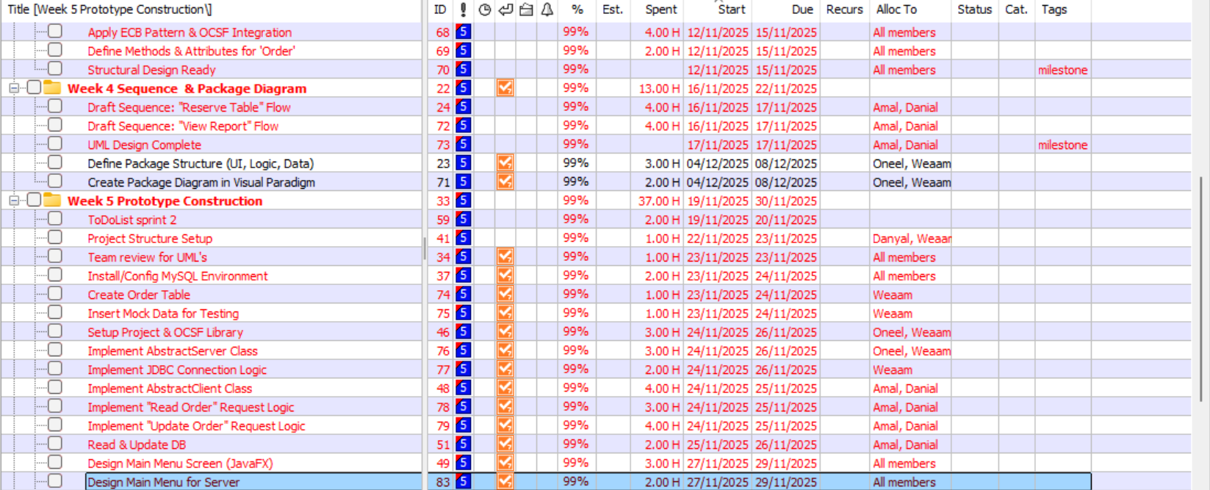
Screenshot from ToDoList:

